Clash of Clans War Predictions
Justin Torres
ITCS 3156

Introduction
In the mobile game Clash of Clans, players build bases, attack each other with armies of units, and gain benefits by forming groups known as Clans. One of the most rewarding events of the game is Clan War Leagues, which are an event that runs for about a week every month and have a Clan War for each day of the week. Clan Wars in Clan War Leagues have a day of preparing bases, and a day of attacking bases (In Leagues, each Battle Day is the next War’s Preparation Day). Attacks have a score system of Stars, where every attack has 3 Stars: One star for destroying a building called the Town Hall, one for destroying 50% of the base, and one for destroying 100% of the base. Whichever out of eight clans gets the most stars will go up a rank while last place goes down a rank, though depending on the league, this can apply to the top two or bottom two rather than just first and last. I wish to see if an algorithm can be created to predict what League Clans are in based on factors such as the number of members in a clan or Trophies. (Another score system for casual play)
My reason for choosing this dataset is relatively simple; I enjoy Clash of Clans. While I doubt that the algorithms will be anywhere near perfect, (I will elaborate on why in the next paragraph) I want to see how far the algorithms can get. Even if they are still wrong, if the algorithms are able to make close guesses, I will be satisfied.
Two algorithms will be created to predict which clans have certain rankings in War Leagues. By the nature of War Leagues, it is clearly a Classification problem. I believe that the algorithms will not be very accurate, especially because of how much easier it is to gain trophies than to rank up in War Leagues, but the results will likely be coherent at least. There are other reasons that can complicate the ability to predict further, such as clans that serve more as friend groups than for direct gain and some players simply not prioritizing Clan War Leagues. Much of the content explaining where clans tend to end up is from personal experience, having played Clash of Clans since 2014.
Data
A dataset from Kaggle called Clash of Clans Clans Dataset 2023 (3.5M Clans) was used.
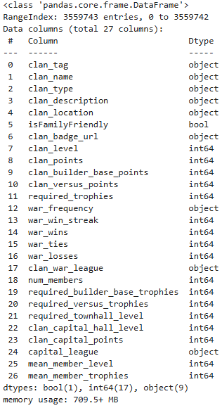
Preprocessing
The dataset is very elaborate and as the name says, there are many rows. So many that it is over 700 MB. As such, there are certain things to check for before starting. First, as they were irrelevant, the following columns were removed: clan_name, clan_description, clan_location, clan_badge_url, war_win_streak, isFamilyFriendly. I then dropped rows that I deemed to be unqualified for the problem. These conditions were: Clan War League must have a rank, the clan must have at least one member, the clan must have won at least one war, and the Clan Capital must have a rank. (Clan Capital was a feature added in 2022 that while it is irrelevant to the problem, having a rank proves the clan has been active in the last two years.) After that, I dropped null values, got the first 15,000 rows of data, and dropped remaining columns that I was sure I didnt need. These were the following: clan_tag, war_frequency, clan_type, required_builder_base_trophies, clan_capital_hall_level, clan_capital_points, capital_league, clan_builder_base_points, war_ties, war_losses, required_versus_trophies, required_townhall_level, and mean_member_level.
Analysis
The remaining columns used are clan_level, clan_points, clan_versus_points, required_trophies, war_wins, num_members, and mean_member_trophies. These are all int64 values that give information on the performance of clan members in a casual setting. These are used to predict another column, clan_war_league, that serves as a ranking in a more competitive setting, and uses objects to store the data. This column will serve as my goal for both algorithms.
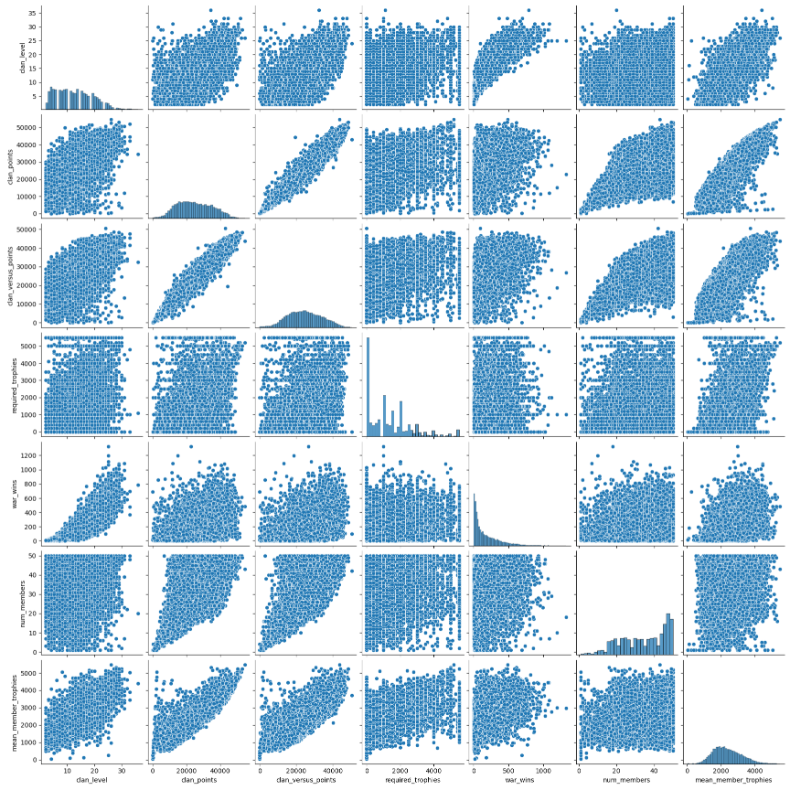
Generally, most of the columns have positive correlations with one another. However, there are exceptions for visualizations involving required_trophies and num_members. However, num_members still avoids negative correlation while clans with high required_trophies typically have other factors being high as well. Because of this, those columns will be kept.
Methods
The first algorithm I decided on was using Logistic Regression to predict Clan War League rankings. Clan War Leagues are divided into several ranks. These ranks are Bronze, Silver, Gold, Crystal, Master, and Champion, and each has three levels. (Bronze has Bronze III, Bronze II, and Bronze I, progressing in that order.) This makes the ability to predict classes that Logistic Regression provides very useful. This will be done using SciKitLearn’s methods for Train Test Split, Logistic Regression, Label Encoder, and StandardScaler for the learning, and display results using SciKitLearn’s Classification Report, Confusion Matrix, and Accuracy Score.
Because the target I am searching for is a class rather than a numeric value, I also wanted to see how Gaussian Naïve Bayes would perform. This will be done using SciKitLearn’s methods for Gaussian Naïve Bayes, One Vs Rest Classifier, Train Test Split, and Label Encoder for learning, and Classification Report, Confusion Matrix, and Accuracy score to show results.
How the algorithms work
This section serves as a transition between the Method and Results sections, explaining both the algorithms and the setup.
Logistic Regression
First, a Label Encoder is used to label and properly order the classes of the Clan War League Column. The y value is Clan War League alone, while the X value is all remaining columns. The Train Test Split is performed with a test size of 30% and a random state of 42. Using Standard Scaler, the training X values are put through fit transform while the testing X values are put through transform. Logistic Regression is performed with Limited Memory BFGs, One Vs Rest, Balanced Class Weight and Max Iterations of 1000, and the data is fit. The value y_hat is then calculated through a prediction, and the data is displayed in a Classification Report, Confusion Matrix, and Accuracy Score.
Gaussian Naïve Bayes
The same Label Encoder is used to label and order the classes of the Clan War League Column. The Clan War League Column is put into the y value, while the X value is every remaining column. The Train Test Split is once again performed with a test size of 30% and a random state of 42. Once again, the training X values are put through fit transform while the testing X values are put through transform in Standard Scaler. Gaussian Naïve Bayes is initialized and the One Vs Rest Classifier is run with Gaussian Naïve Bayes as an input. It is then fit to the y_trn and scaled X_trn values. Next, y_hat is initialized through the One Vs Rest Classifier predicting using the scaled X_tst value, and Accuracy Score is run using y_tst and y_hat. The Confusion Matrix is then created using y_tst and y_hat, and finally, the Accuracy Score, Confusion Matrix and Classification Report are displayed.
While the accuracy scores and classification reports serve to measure performance, the Confusion Matrix will show what every guess was, so that the almost correct guesses can also be seen and acknowledged.
Results
For Logistic Regression, the final accuracy was 27.4%.
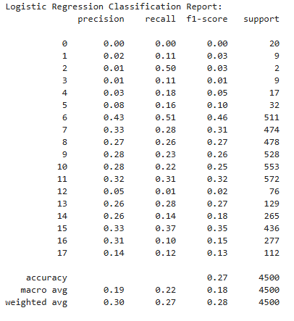
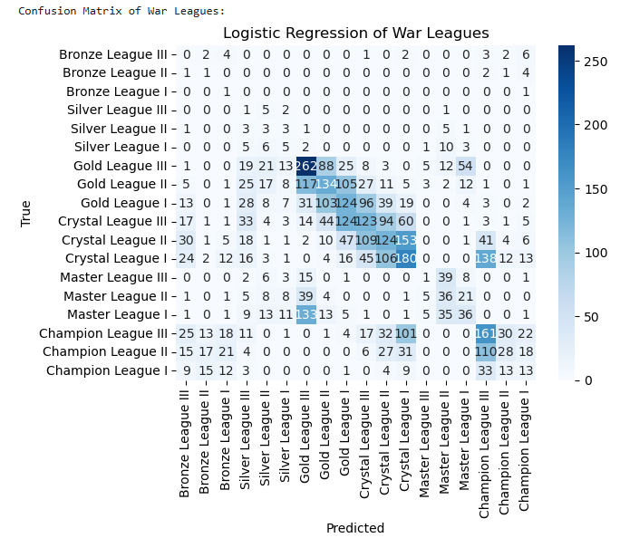
For Gaussian Naïve Bayes, the final accuracy was 29.6%.
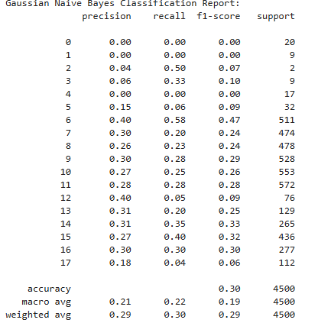
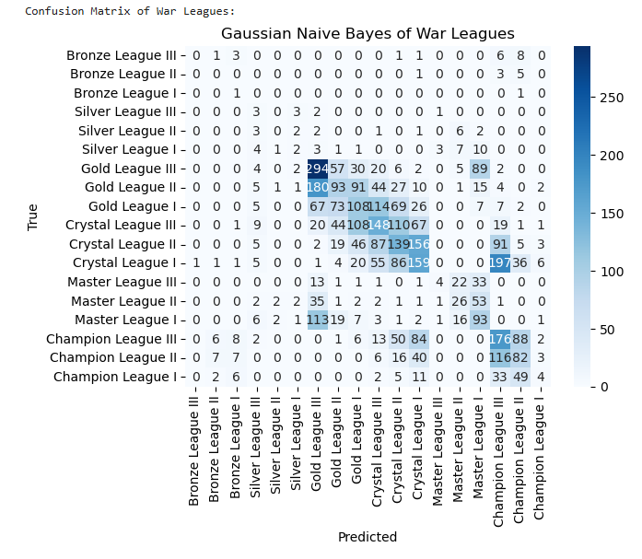
While close, it seems that Gaussian Naïve Bayes was the more accurate algorithm for this dataset. I find the low scores believable, considering that the data compares measurements of the actions of players in a more casual setting (Trophy counts and normal war wins, number of members, required trophies, and clan level) with a competitive one (Clan War Leagues). These results naturally have a difference as they also measure how players can perform against players of any skill level vs exclusively higher skill levels.
In particular, the algorithms were able to do a great job at telling when clans were in the Gold and Crystal leagues, especially Gold III. The algorithms also did a good job of predicting when clans are in Master I, Champion III, and Champion II. This makes sense to me because they are the leagues where the most serious players are. The low score of Champion I makes sense because the higher leagues allow less clans to move up, and more will fall as a result.
I believe that the lack of predictions for Master League III at all is because Crystal League is usually the highest that casual clans get, while most competitive clans are in Champion League, possibly falling to Master I or II before climbing back up. This likely makes Master III an in-between spot of sorts where it can be harder to differentiate the casual and competitive clans. It makes sense that the league where casual and competitive clans meet would be where it is the hardest to tell where clans would be based on casual performance. This would also explain why there are so many cases of mistaking Crystal I for Champion III and vice versa.
The lack of clans in the Bronze and Silver Leagues also makes sense because from the conditions I provided at the beginning, those clans would be the ones players are most likely to leave for better clans, thus they would be a lot of the empty clans that got filtered out of the algorithms, and many people would flock to Gold League, where people start to get good rewards, but don’t need to take the game overly seriously.
I believe that the many mistakes between Master I and Gold III are because there are also the players with high casual rankings that don’t prioritize clan wars. As stated before, Gold League is where a lot of the high leveled players who don’t prioritize Clan War League end up. There are also many clans that are simply friend groups rather than organized teams, and those are usually in Gold League as well.
It is also worth noting that most of the mistakes in the algorithm are a single league off. This makes sense, as every Clan War League ends with two clans moving up a league and two moving down a league. Because there a required winners and losers, it makes sense that there would be so many small mistakes like that.
Conclusions
One of the biggest takeaways for this project for me was the importance of the Confusion Matrix. The ability to see what every specific guess was and visualize it helped greatly in achieving my goal of seeing how well algorithms could perform in predicting Clan War Leagues. Based on the data that could be used, there were a lot of small mistakes that make sense given how the game works, and my own experience playing Clash of Clans for a long time helped me think about and realize the greater factors that the dataset cannot provide that would cause incorrect guesses.
Overall, the biggest challenge that I had was figuring out how to display and order the labels of every Clan War League, which was the point where I started using ChatGPT for help with errors I got or for how to use tools like reordering labels. (Discussed in Acknowledgements, References, and in the Jupyter file where it is used) Overall, my expectations for using these algorithms was met well.
References
Referencing the dataset used, ChatGPT for the use of it (elaborated on in Acknowledgements) and the official website for Clash of Clans. (Not sure how else to reference the game for this type of report.)
asaniczka. “Clash of Clans Clans Dataset 2023 (3.5M Clans).” Kaggle.com, 2023, www.kaggle.com/datasets/asaniczka/clash-of-clans-clans-dataset-2023-3-5m-clans. Accessed 12 Dec. 2024.
OpenAI. “ChatGPT.” ChatGPT, OpenAI, 10 Dec. 2024, chatgpt.com/.
Supercell. “Clash of Clans.” Supercell, 2000, supercell.com/en/games/clashofclans/.

Acknowledgements
I did use ChatGPT to learn to use certain parts of the algorithms used in this project as well as solving syntax errors. The cells that I did this for have comments acknowledging this fact. The tasks I used ChatGPT for are the following:
- Learning to manually order labels in a dataset by name to both display and organize data.
- Figuring out how to use the solver, multiclass, and class weight inputs for SciKitLearn’s Logistic Regression method.
- Importing SciKitLearn’s Classification Report. It was used again to add zero_division to fix an error.
- Heatmap syntax (I’m bad at visualizing data) and implementing the order of labels mentioned in the first bullet.
- Using SciKitLearn’s Gaussian Naïve Bayes and OneVsRestClassifier methods.

Source Code Link: https://github.com/jtorres1591/ITCS3156FinalProjectJustinTorres

Dataset Link (It is over 700 MB, making it too big for GitHub, even when compressed.):
Link to Clash of Clans Clans Dataset 2023 (3.5M Clans): https://www.kaggle.com/datasets/asaniczka/clash-of-clans-clans-dataset-2023-3-5m-clans

